From: https://dailystormer.su/ratty-old-jew-jon-leibowitz-shills-wuhan-lab-theory-on-steven-colbert-show/
Via: https://www.unz.com/aanglin/ratty-old-jew-jon-leibowitz-shills-wuhan-lab-theory-on-steven-colbert-show/
Author: ANDREW ANGLIN • JUNE 18, 2021 • 2,300 WORDS • 125 COMMENTS
Ratty Old Jew Jon Leibowitz Shills Wuhan Lab Theory on Steven Colbert Show
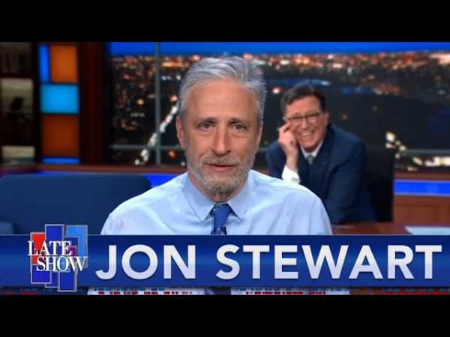
This news is coming to you a few days late, because I haven’t totally been on the ball this week – also, who the hell pays attention to Stephen “Colbert” (real name Colbert, pronounced “Colbert”).
On Monday, the ratty old Jew Jon “Stewart” (real name Leibowitz) came on Colbert’s show (pronounced “Colbert’s show”) and did a bit on how the alleged deadly coronavirus came from a virus research laboratory in Wuhan, China.
In terms of physical Jewish comedy, it was a pretty good bit. I don’t have a problem admitting that. Jews, like black people, have historically gotten favor with whites by being amusing. Unlike blacks however, Jews have several other tricks in their bag – such as the ability to manufacture monumental lies and then disseminate them through their media apparatus.
Stephen Colbert played the straight man, which is the reverse of their bit they used to do together on Comedy Central. What Colbert did was present the previous narrative, as an eccentrically discomposed Leibowitz presented the new narrative. This leads the audience from the previous “absolute fact” to a new and opposite “absolute fact.”
You used to literally be censored and banned from social media for saying the virus came from a Chinese lab, and we are now entering into a paradigm where you will get banned for saying the virus came from bats. Facebook actually had to announce that they would no longer be banning people for saying the virus came from a lab. Eventually, you will be banned for bringing up the fact that the media used to say it was from bats. It’s full “we’ve always been at war with East Asia.” Total information control. Imagine being inside the head of a person who is capable of thinking this is reasonable.
Donald Trump continually called the supposedly new coronavirus the “China virus.” This, we were told by the Jewish media for a year, was pure evil. Now, this old establishment liberal Jew power-player from the Bush era is being rolled out to say all of the exact things Trump was attacked and demonized (again) for saying. Leibowitz was laying it on real, real thick.
A Jon Leibowitz propaganda piece is no small thing. This man was extremely influential on millennials, and probably some significant number of older people as well. He hosted the Daily Show from 1999 to 2015, quitting and more or less disappearing when he was only 52. Apparently, he was going through some kind of personal crisis, as there is really no other reason for a man to retire at 52. (He must still be in this personal crisis, or he would have started working again.) These days, he is only rolled out for special occasions – such as a complete and total narrative reversal, where the media is asking people to believe the exact opposite of what they were asking them to believe a month earlier.
The narrative of course is that these people are just now figuring it out, because of “new information.” But there actually is no new information. What they are saying is the same thing Tom Cotton and Mike Pompeo were saying nearly a year and a half ago now, and they are saying it with the same premises.
Obviously, the narrative is designed to drum up a war with the Chinese. That’s why Mike Pompeo and other neocons were saying it last year, and that is why, now that there is a Democrat in power, the Jews are saying it this year.
Most likely, the “deadly coronavirus” is simply a rebranding of the normal flu. You might say “well what about the tests?” Well, the tests are really confusing and non-specific. It seems to me that they could very easily be testing for one of the many coronaviruses that already exists. As you can read on the CDC’s own website, the common cold is typically caused by coronaviruses. Most people who have “symptomatic” coronaviruses have symptoms that are identical to what the CDC describes as symptoms of the common cold.
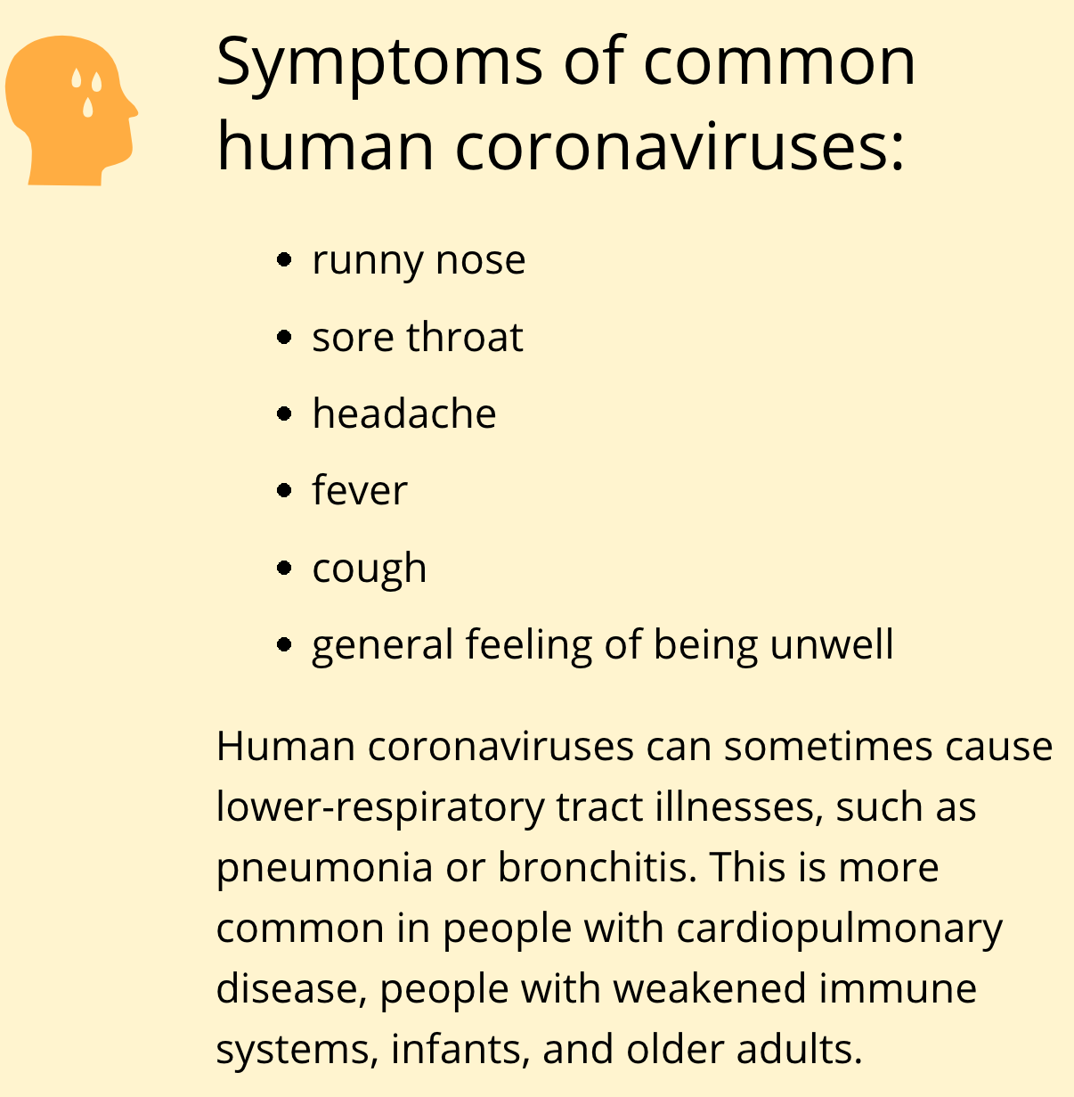
Flu and cold viruses mutate, so it is possible that a lab identified a new coronavirus mutation, which was really just a standard respiratory virus of the kind we have been familiar with for a very long time, and invented a new test for it.
It’s also possible that there is no virus at all that they are testing for – that the PCR tests are totally ridiculous and don’t really test for a virus. The media and Anthony Fauci both admitted that if you run too many cycles on the PCR test, it will give everyone a positive test, as it is testing for genetic matter that exists in all people naturally.
People don’t know this, but electron microscopes are almost completely useless in identifying viruses. All they are able to see is a bunch of different gray blobs floating around.

That might be a coronavirus, or it might be some other kind of gray circle. But you clearly could not tell the difference between one coronavirus and another using this technique.
So, you can figure that out.
What no one has to figure out is this: everything that has been done in response to the coronavirus was preplanned.
Thus far, they have:
- Stripped everyone of their basic civil rights
- Transferred trillions of dollars’ worth of wealth from the middle class to the ruling elite
- Destroyed virtually all small businesses and independent livelihoods
- Forced Donald Trump out of office
- Shut down international travel
- Instituted a total electronic control grid police state
- Institutionalized inexplicable coerced gene therapy injections
- Accustomed people to systematic dehumanization and depersonalization for the sake of the greater good
- Manipulated the social order on a massive scale, leading to divorces, race riots, and other human problems
- Launched a global campaign to fight against global warming, which will include more of everything else on this list
All of these things were things that the ruling elite that meets at places like Davos had on their agenda already.
This is not a response to a random event. It is a planned response, that was planned long before anyone ever heard of “the coronavirus” or “Wuhan, China.” No one can argue otherwise in good faith.
So what is the argument, exactly? That they planned all of this, then sat down and said, “now we just have to wait for a virus to leak from a Chinese lab, and we’ll be set to go”?
Makes zero sense.
The intelligence establishment has to have pulled the trigger on this, and the most logical explanation for how that was done was to take an illness that already exists – the cold and the flu – and relabel it as a new plague.
This is the same thing they’ve done with the race stuff: black people have always been poor, they have always committed extreme amounts of violent crime, which had led to run-ins with the police. Just all of a sudden, this became a problem.
Just so, we’ve always had hurricanes and tornados, droughts and floods, but they’ve announced, all of a sudden, that these things are caused by electricity and cow farts.
This is the big lie that Adolf Hitler warned us about: they take something that already exists, that everyone knows about and thinks is bad but doesn’t think is a crisis, and they declare that it is a crisis – just all of a sudden.
If you don’t think this is possible, just look at the tranny phenomenon. Children would always play pretend, and some would pretend to be the opposite sex. But all of a sudden, this is a crisis, the children are all souls stuck in the wrong bodies, and we need to inject them with hormones and mutilate their sexual organs.
In 2017, they told us that 0.7% of children were “trans.” By 2019, that number had become 2%. In May of this year, they announced that it was 9.2% – nearly 1 in 10.
Do you believe that all throughout history, 1 in 10 people were secretly trannies, and we just found out about it now? Does that make any sense to any single person on earth? If not, then this is a fake problem. The solution to it they are offering is even more brutal than the solution they give for the coronavirus: they are sexualizing children, they are turning them into science experiments.
If the people who run our society would be so bold as to do this to children, how could you imagine they would not be so bold as to fake a virus?
Obviously, the difference between trannies and the coronavirus is that the Chinese are going along with the coronavirus, whereas they are not going along with the tranny agenda. So you think: “well, there must be something there, or the Chinese and the Russians would call it out – especially when the Chinese are being blamed for causing a global pandemic.”
But here’s the thing: if the Chinese were presented with a test that tested for a cold virus that already existed, they wouldn’t know it was fake – at least not at first. If they came out later and said it was fake, they would look stupid for having gone along with it in the first place, and they would lose the faith of their own population.
This was the series of events:
- Chinese scientists in Wuhan were sent a test for a flu virus that was supposedly similar to SARS
- Chinese doctors in Wuhan started using the test and saying that the virus was causing a flu
- The Chinese government said that it was not a big deal and don’t worry about it
- All of a sudden, China shut down the entire city of Wuhan (not like a Western-style lockdown – they closed off entry and exit to the entire city, but allowed people in the city to roam freely)
- China told people all over the country to wear masks and go home early after work and closed down public restaurants
- China reopened Wuhan, and said that it wasn’t that big of a deal
- China ordered a total stop to random testing
- China basically only had mask restrictions, letting people do whatever
- China released a vaccine that has no side effects
- China has been fully open for about a year
The vaccine having no side effects implies it is a placebo. Everything about the series of events implies that China at first didn’t know what was going on, then figured it out, but couldn’t admit that the West deceived them on that large of a scale, so they had to figure out how to manage things, covering up that they fell for a hoax.
Why Would the Media Tell the Truth?
Right wingers who have been promoting this Wuhan lab leak theory need to ask themselves a very simple and very important question: why would the media all of a sudden start telling the truth about the virus?
Nothing has changed. Nothing at all. There was no big leak of information or any other type of revelation. All of a sudden, the media turned on a dime and started saying “Wuhan lab leak.” No one pressured them into doing this. There was no “Wuhan lab truth” group that published a new load of research.
There was always just that one Hong Kong woman who was funded by Steve Bannon and his billionaire Chinese criminal friend.
Steve Bannon and this Chinaman are attempting to overthrow the government of China – so they have some special interest in this agenda.

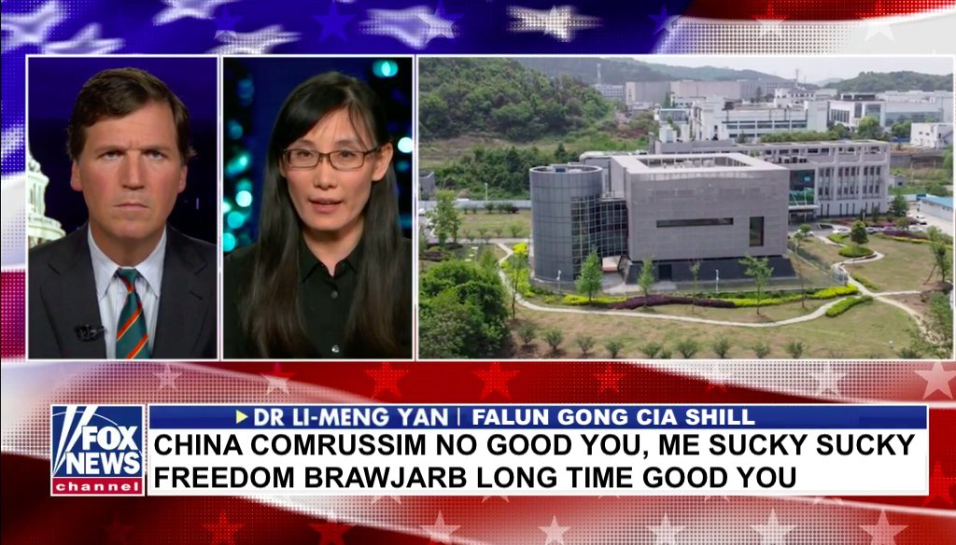
I’ve heard other variants of my own theory.
For example, I’m heard it theorized that via their funding and involvement in the Wuhan lab, Fauci and his people released a mostly harmless coronavirus from the Wuhan lab. This is possible, maybe. I’m not a scientist. But I would think releasing a biologically engineered virus would be very dangerous. The virus story says that viruses mutate constantly and can rapidly mutate, so one would think that a bioweapon would be totally impractical. With anything regarding a real new virus, I am left wondering why that would be needed, when it is clearly possible to do everything they’ve done with no new virus.
Furthermore, if there was any relationship between any virus and the lab at Wuhan at all, I just don’t believe the government and media would say that. But Fauci’s NIH did have connections to the Wuhan lab, and no one can deny at this point that there is a massive media agenda to get people to believe this is from a Chinese lab.
So if there was anything related to that lab in the true story, why would they lead you down that path?
Remember that with 911, they didn’t ever want to talk about the fact that virtually everyone involved was from Saudi Arabia. They censored the pages in the 911 commission that talked about involvement by Saudi intelligence. They didn’t want to talk about that because if you start looking at Saudi intelligence, you start talking about Israel.
With all of these schemes and scams, they will consistently distract you from the truth. Much of the alternative media is now agreeing with the mainstream media on a fundamental aspect of the single biggest lie in all of human history. At that point, it is time to reflect.
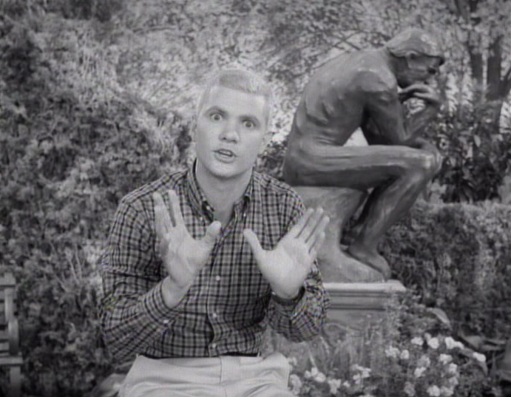
(Republished from The Daily Stormer by permission of author or representative)
← Tucker Carlson Finally Addressing the F...

